LAUNCHING THE SOFTWARE AND USAGE
The MCE software runs on Spyder (3.9) which is a free and open-source environment written in Python which can be downloaded on Windows, Linus and MacOS and is available to download from https://www.anaconda.com/
Follow the instructions from the website and download the version that suits your computer specifications.
Open Spyder (3.9) from the Anaconda Navigator window.

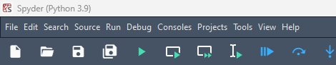

After Spyder has been launched click here and navigate to the appropriate directory to open the GUI.py file from the src directory.

After opening the GUI.py file, click the run button to launch the software which opens in another window.

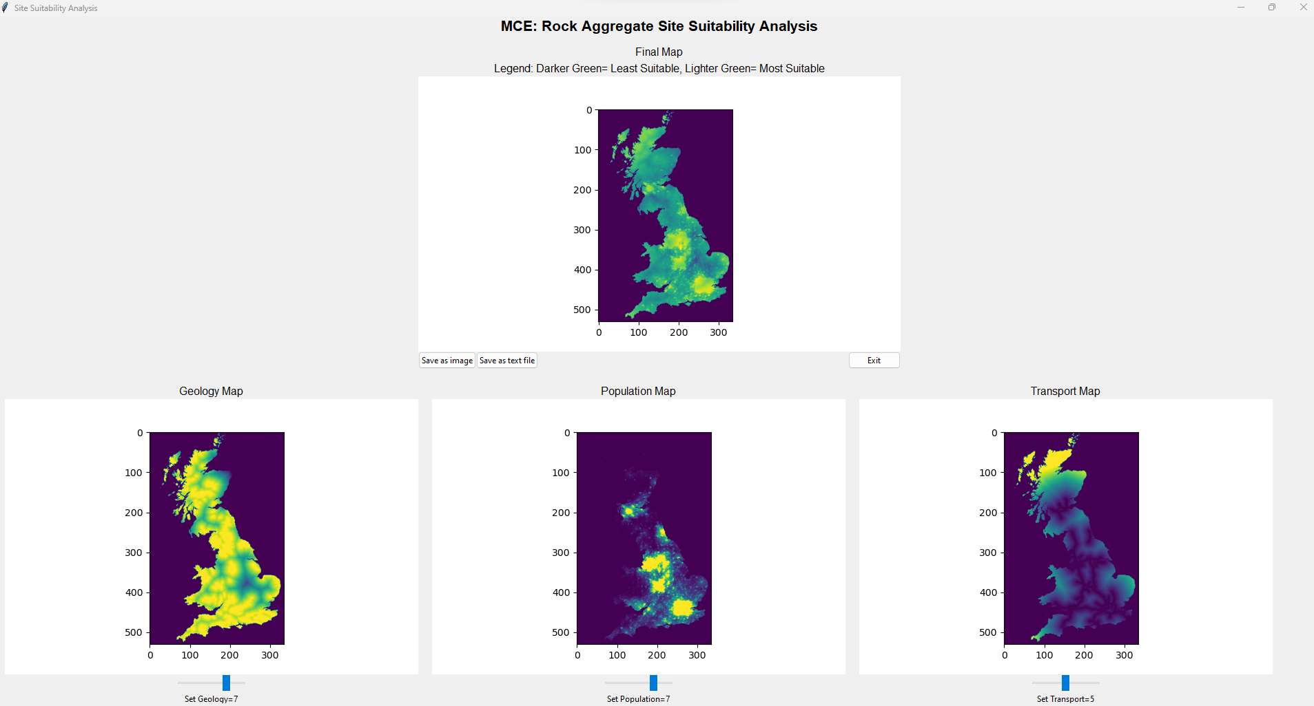
1.Title of Software
2. Final Map Frame
8. Save image
9. Save as text
3. Legend
10. Exit

5.Population Map Frame
5. Population Map Frame
6.Transport Map Frame
4.Geology Map Frame

7.Sliders
In the software as illustrated above, areas numbered 2,4,5 and 6 display the respective maps.
When the sliders are moved in either the geology, population, or transport map, it is displayed in the final map frame to represent the MCE. When the desired weights are applied in the slider by using the mouse, the final MCE can be saved in the output directory. This is executed by clicking on 8 (save as image) to save the final output as an image or 9 (save as text) to as a txt file in the output directory located in the folder.
Legend (3) makes it easier to interpret the result from the final map.
The exit button when clicked closes the software window.

